Amazon Bedrock
Amazon Bedrock is a fully managed service that makes foundation models from leading AI companies accessible through a unified API. Whether you're building conversational AI applications, content generation tools, or automated analysis systems, Amazon Bedrock provides the infrastructure and models you need to bring generative AI capabilities into your applications.
Let's explore how Amazon Bedrock works, understand foundation models, and learn how to leverage its capabilities in your development workflow.

The Journey to Generative AI
Before we dive into Amazon Bedrock's capabilities, it helps to understand the evolution that brought us here. The path from traditional computing to today's generative AI represents a fascinating progression in how machines process and create information:
- Rule-Based Systems: Early AI relied on explicit programming and fixed rules
- Machine Learning: Introduced data-driven pattern recognition
- Deep Learning: Enabled complex pattern processing through neural networks
- Generative AI: Achieved the ability to create new content from learned patterns
This evolution has culminated in foundation models that can understand context, generate human-like responses, and even create multi-modal content across text, images, video, and code. Let's explore how Amazon Bedrock makes these powerful capabilities accessible to developers and organizations.

Working with Amazon Bedrock

Console Experience
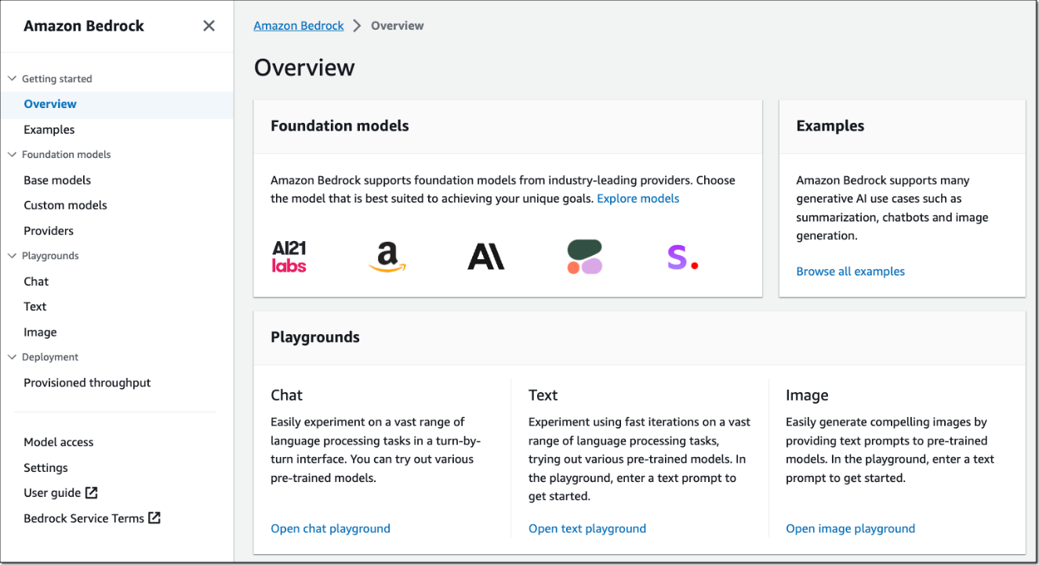
The Bedrock console provides an excellent starting point for experimenting with foundation models.
Here's how to begin:
- Choose a Playground
  - Select either the Chat & Text playground for language tasks
  - Or choose the Image playground for visual generation
- Select a Model
  - Browse available foundation models from different providers
  - Each model has specific strengths and capabilities
  - Review model descriptions to find the best fit for your use case
- Configure Parameters
  - Adjust temperature to control response creativity
  - Set top_p for response diversity
  - Modify other model-specific settings as needed
- Enter your Prompt
  - Write clear instructions for the model
  - Be specific about your desired output
  - Experiment with different prompt structures
5. Review Generated Output
a. Evaluate the model's response
b. Try multiple runs to understand variation
c. Note how parameter changes affect results

Amazon Bedrock API
Here's how to use Bedrock's InvokeModel API for text generation:
import boto3
import json
# Initialize Bedrock client
bedrock_runtime = boto3.client('bedrock-runtime')
model_id_titan = "amazon.titan-text-premier-v1:0"
# Text generation example
def generate_text():
payload = {
"inputText": "Explain quantum computing in simple terms.",
"textGenerationConfig": {
"maxTokenCount": 500,
"temperature": 0.5,
"topP": 0.9
}
}
response = bedrock_runtime.invoke_model(
modelId=model_id_titan,
body=json.dumps(payload)
)
return json.loads(response['body'].read())
generate_text()
The InvokeModel API is a low-level API for Amazon Bedrock. There are higher level APIs as well, like the Converse API. This course will first explore the low-level APIs, then move to the higher-level APIs in later lessons.

Common Use Cases
Amazon Bedrock's foundation models can power a wide range of AI features in your applications. Whether you're building customer-facing tools or internal solutions, here are some popular ways developers are using Bedrock:
- Content generation
- Chatbots and virtual assistants
- Image creation
- Code assistance
- Text analysis
Whether you're generating text, creating images, or building conversational interfaces, you can start with simple API calls and gradually expand your implementation. As you continue through this course, you'll learn more advanced techniques and best practices for working with foundation models through Amazon Bedrock. The possibilities are vast - now it's time to start building!

Additional Resources:
- Amazon Bedrock Developer Guide
- Bedrock API Reference
- AWS SDK for Python (Boto3) Documentation

